Microfluidics 110Y and 110L

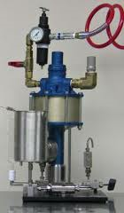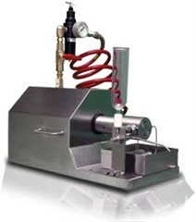

Materials
- E. coli sample in ice
- 200ml 70 % EtOH
- 3 liter H₂O
- Microfluidizer
- Glass tube

Procedure
- Connect high pressure system to microfluidizer. Connect glass tube to sample loading position. Connect plastic tube to waste.
- Check microfluidizer is turn off. Add H₂O to glass tube. Turn on high pressure system pump slowly.
- Wash microfluidizer chamber three times with H₂O. Wash microfluidizer chamber once with buffer. Cool microfluidizer chamber with ice.
- Load sample and break cell 3-5 times.
- Wash microfluidizer chamber three times with H₂O. Wash microfluidizer chamber once with 70 % EtOH.
- Keep 50ml 70 % EtOH in glass tube. Turn off high pressure system. Turn on microfluidizer to release pressure and then turn off it.
- Dissolve ice with H₂O.
- Separate high pressure system with microfluidizer. Collect plastic tube well. Cover sample loading position with aluminum foil.
- Clean up microfluidizer and keep dry.

