QuikChange II Site-Directed Mutagenesis

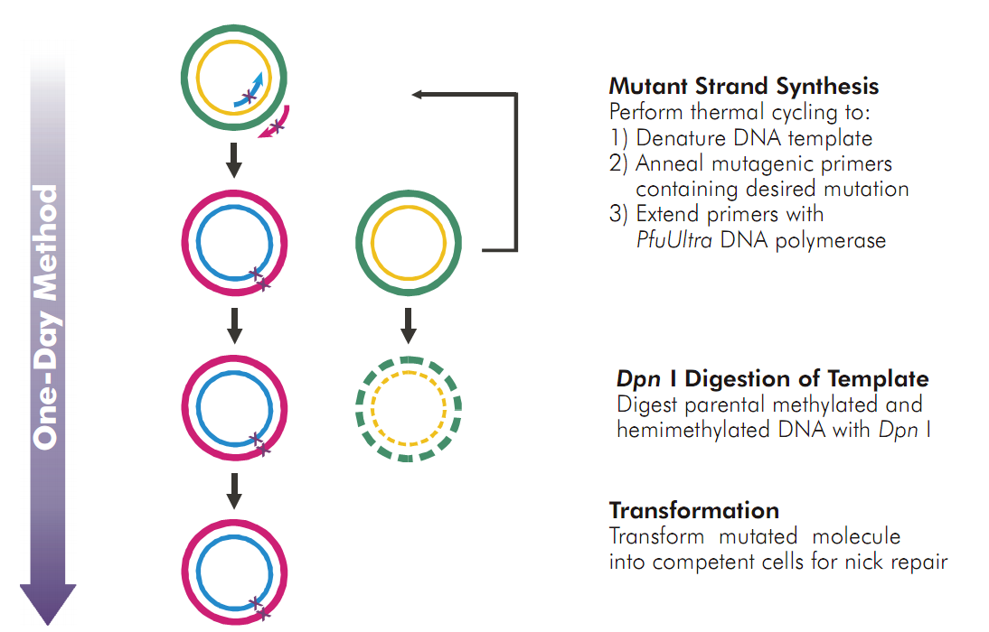

Primer Design
Primers should be between 25 and 45 bases in length.
The desired mutation (deletion or insertion) should be in the middle of the primer with 10~15 bases of correct sequence on both sides.

Mutant Strand Synthesis Reaction

Prepare the control reaction as indicated below:
5 μl 10x reaction buffer
2 μl (10 ng) control plasmid (5 ng/μl)
1.25 μl (125 ng) control primer #1 [34-mer (100 ng/μl)]
1.25 μl (125 ng) control primer #2 [34-mer (100 ng/μl)]
1 μl dNTP mix
38.5 μl ddH₂O (final reaction volume to 50 μl)
Then add
1 μl PfuUltra HF DNA polymerase (2.5 U/ μl)
Prepare the sample reaction(s) as indicated below:
5 μl 10x reaction buffer
X μl (5~50 ng) dsDNA template
X μl (125 ng) primer #1

X μl (125 ng) primer #2

1 μl dNTP mix
X μl ddH₂O (final reaction volume to 50 μl)
Then add
1 μl PfuUltra HF DNA polymerase (2.5 U/ μl)

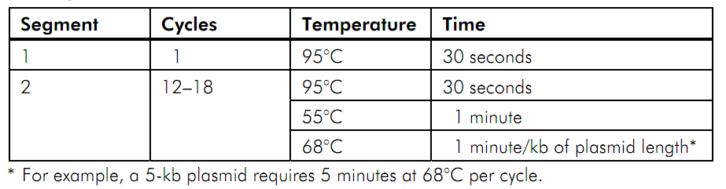

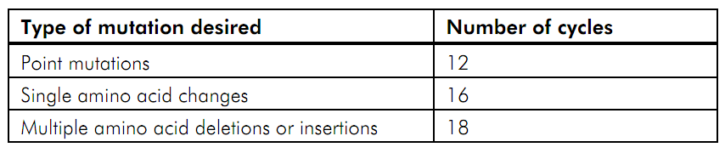

Note If desired, amplification may be checked by electrophoresis of 10 μl of the product on a 1% agarose gel.

Dpn I Digestion
Add 1μl of the Dpn I restriction enzyme (10 U/μl)
at 37℃ for 1 hour

Transformation of XL1-Blue Supercompetent Cells
1. Transfer 1 μl of the Dpn I-treated DNA to 50 μl the supercompetent cells.
incubate the reactions on ice for 30 minutes.
2. Heat pulse the transformation reactions for 45 seconds at 42℃ and then place the reactions on ice for 2 minutes.
3. Add 0.5 ml of LB and incubate the transformation reactions at 37℃ for 1 hour with shaking at 225~250 rpm.
4. Spread cells on LB-ampicillin agar plates (containing 80 μg/ml X-gal and 20 mM IPTG)
5. Incubate the transformation plates at 37℃ for >16 hours.

