Research Interest

Structural and functional studies of DNA/RNA degradation nucleases in protection or killing of cells

Activation of nucleases may result in nucleic acid degradation and lead to contradictory consequences- either protection or killing of cells. A variety of non-specific nucleases have been discovered in prokaryotes and eukaryotes that are triggered during cell defense or programmed cell death. We are interested in understanding and comparing the regulation strategies, nucleic acid recognition methods and catalytic mechanisms of these nucleases using a combination of structural, biophysical and biochemical approaches.

Two types of sugar non-specific nucleases have been identified in bacteria to take part in host defense. The first, a family of periplasmic nucleases, including Vvn from Vibrio vulnificus, protect the cell by preventing the uptake of foreign DNA molecules. The Escherichia coli released nuclease-type bacteriacins represent another class of non-specific endonucleases which digest nucleic acids randomly in target foreign cells to induce cell death, thereby improving host cell survival advantage during stress. We have resolved the crystal structures of Vvn and ColE7 in complex with their inhibitors, cofactors or DNA substrates. Based on our structural and biochemical analysis on Vvn and ColE7, we provide a solid foundation for the better understanding of the molecular mechanisms of non-specific endonucleases involved in the protection of bacterial cells and the recognition of DNA by sequence-independent DNA-binding proteins.

We will continue our studies on Vvn and ColE7 and also extend our investigation to the eukaryotic non-specific nucleases that are involved in RNA degradation and programmed cell death. Functional and structural insight into this group of non-specific nucleases is valuable for developing strategies to promote or suppress cell survival machinery.

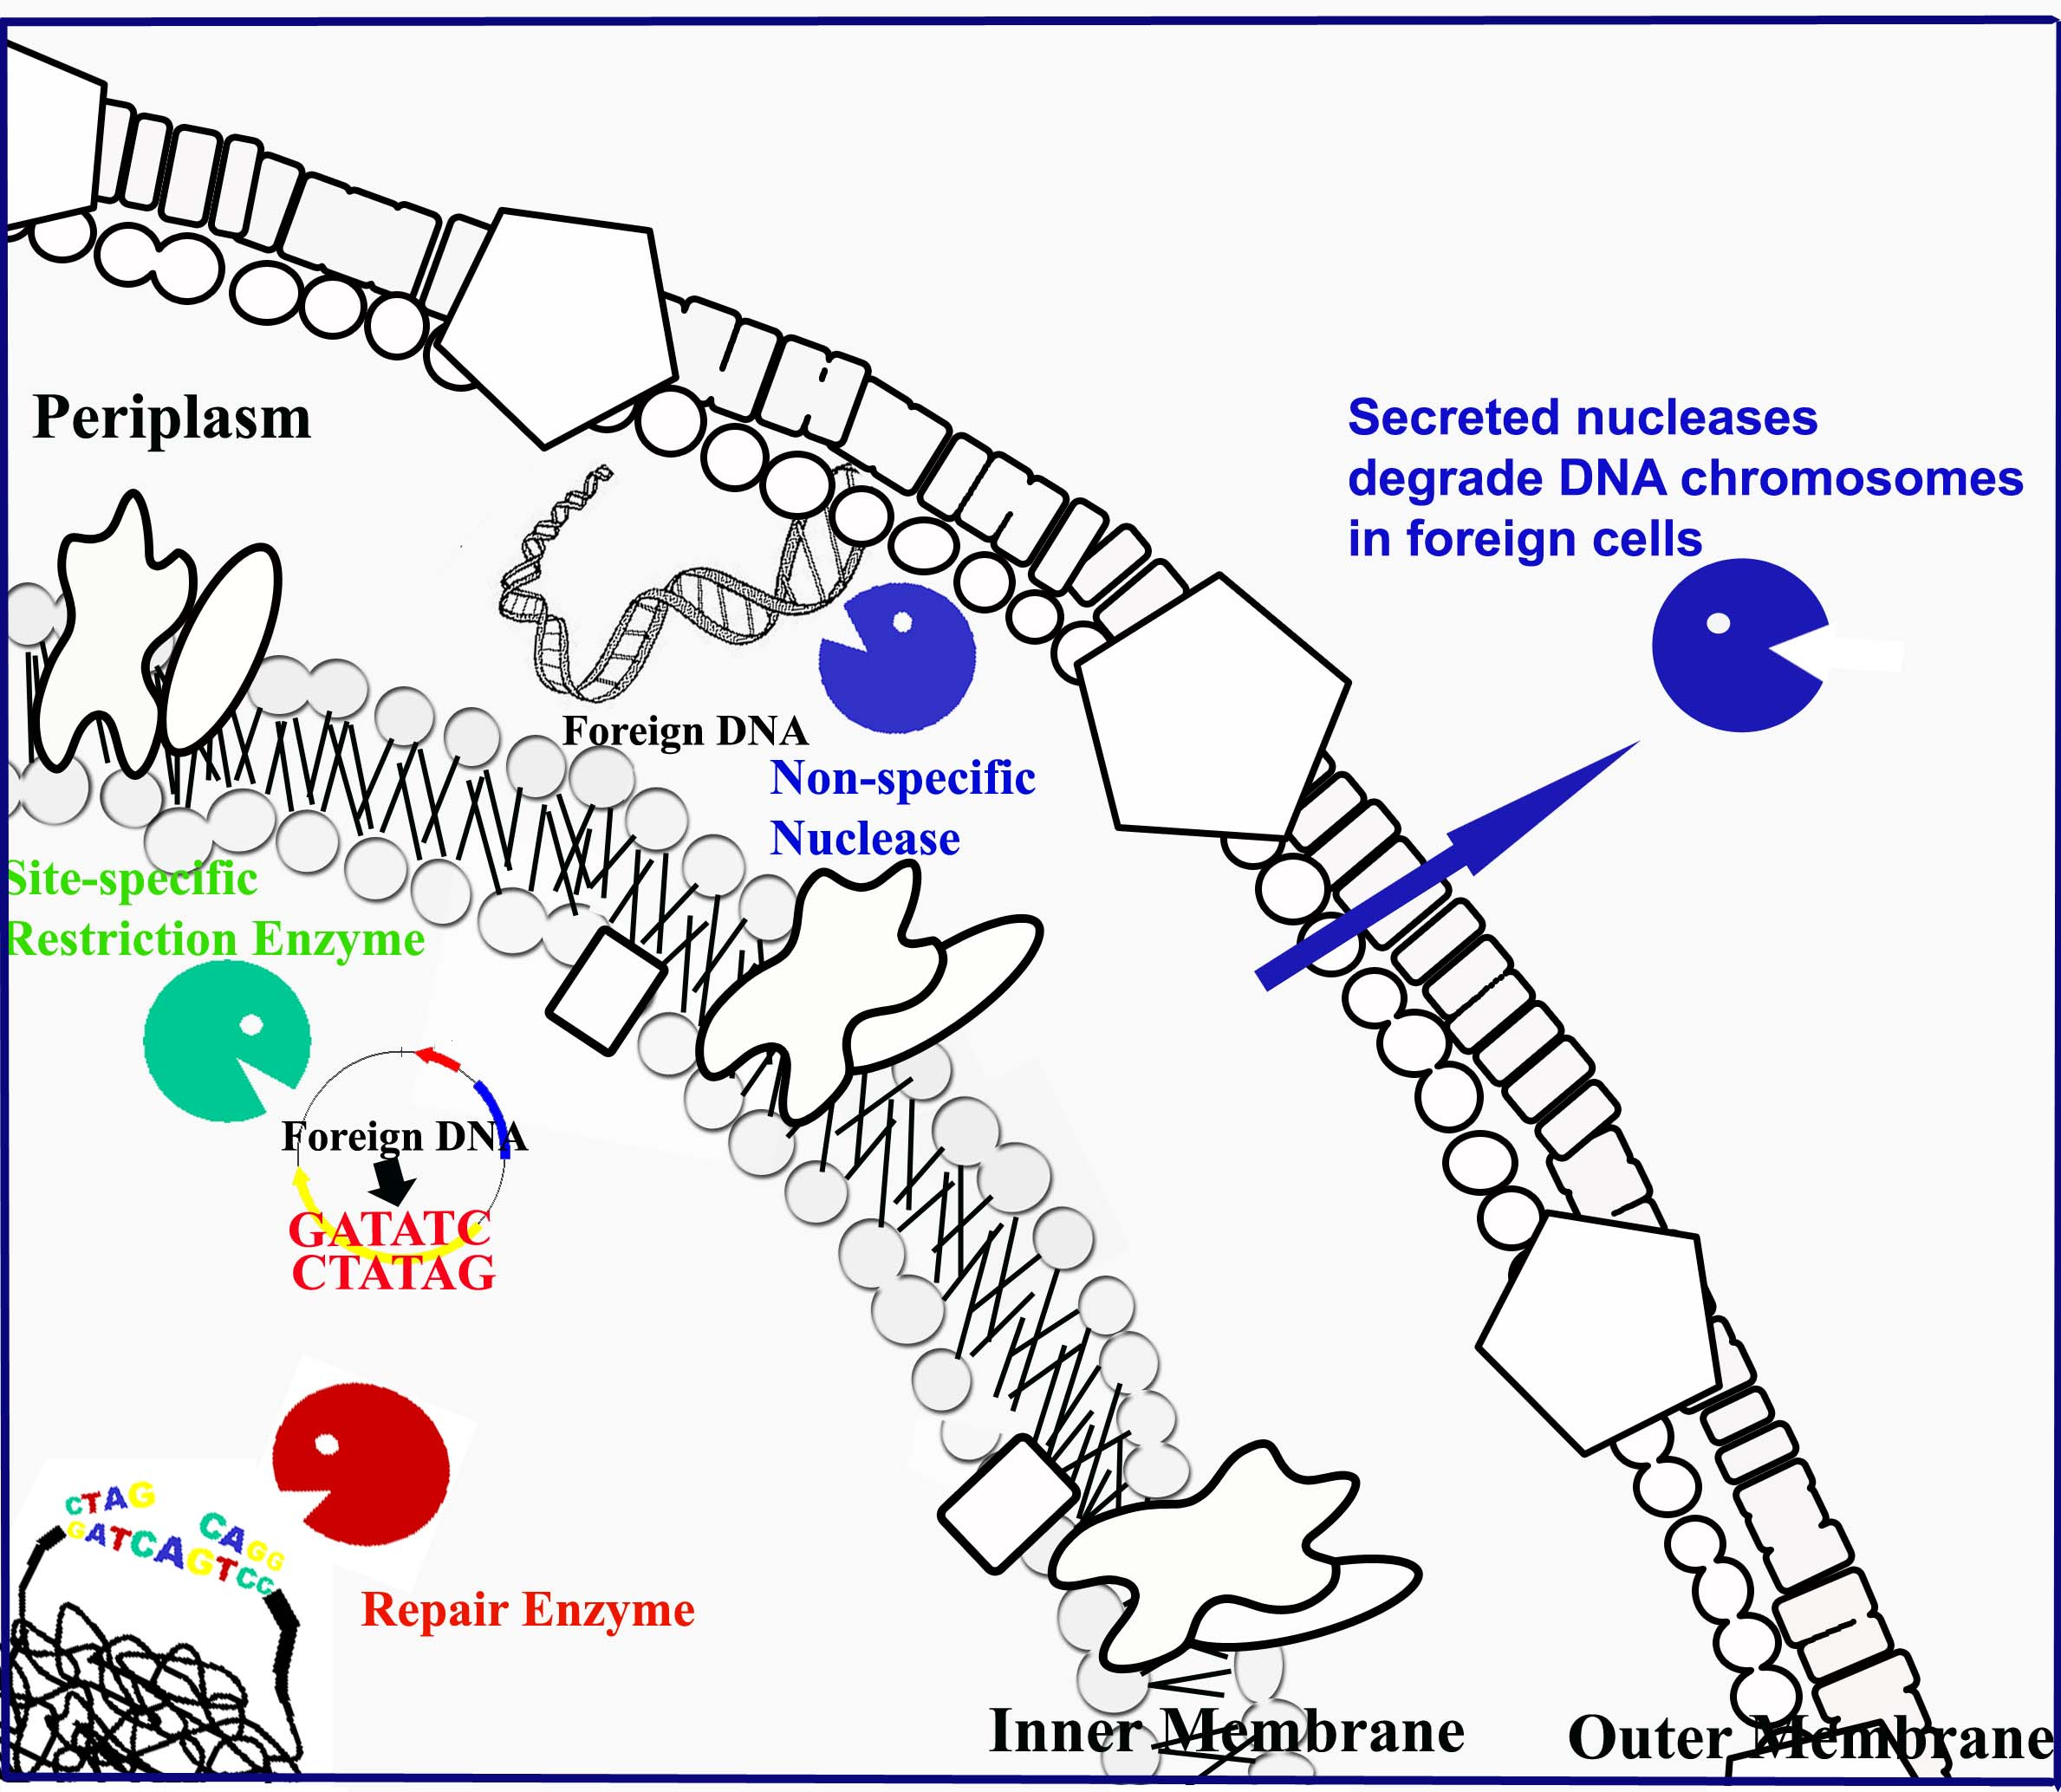

Different types of nucleases constitute a secure network for bacterial host defense against foreign nucleic acids. Restriction enzymes cleave foreign unmethylated DNA in a site-specific manner. Periplasmic nucleases degrade foreign nucleic acids non-specifically in periplasmic space. Cells also release nuclease-type toxins to degrade nucleic acids in foreign cells to increase host survival advantage.

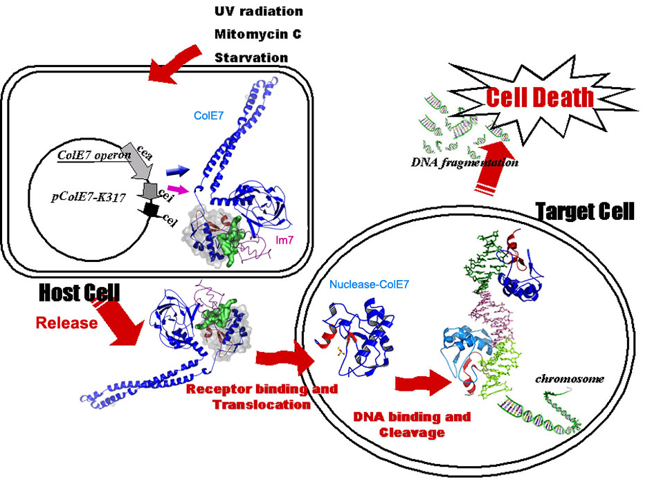
The nuclease-type toxin ColE7 is expressed in host cells and cleaves nucleic acid molecules in foreign cells. In the host cell, ColE7 and its inhibitor Im7 are co-expressed and secreted as a hetero-dimeric complex. ColE7 contains three functional domains, receptor binding, membrane translocation and nuclease domains. After ColE7 binds to the receptor on foreign cells, ColE7 is cleaved during translocation. Only the nuclease domain of ColE7 reaches the cytoplasm of foreign cells for nucleic acid degradation.

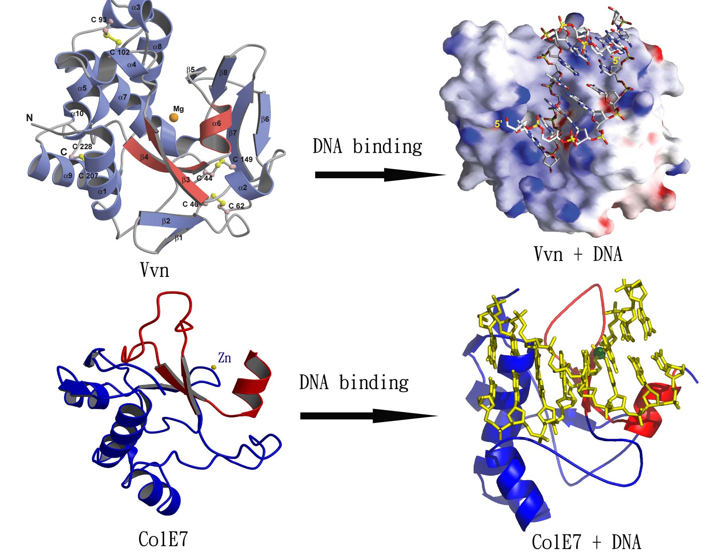
The crystal structures of two bacterial sugar-nonspecific nucleases, Vvn and the nuclease domain of ColE7. The active sites (displaying in red) of the two enzymes contain a common ββα-metal topology (His-metal finger). Upon DNA binding, the ββα-metal fold binds at the minor groove and induces DNA bending slightly away from the enzyme.

