Research Interest
DNA/RNA-binding proteins involved in nucleic acids degradation and translational regulation

We have been working on a number of DNA/RNA-binding proteins involved in nucleic acids metabolism and translation regulation. The overall goal is to discover the structure-based mechanisms of these proteins in nucleic acids recognition, processing and degradation. We use the main tool of X-ray crystallography in combination with mutagenesis, biochemical and biophysical approaches.

We have extended our research from bacterial cell-defending nucleases to eukaryotic RNA-binding proteins and nucleases involved in RNA metabolism for translational regulation and DNA degradation during apoptosis. Our research has provided molecular bases for the regulation, substrate recognition and catalytic mechanisms of these important nucleases involved in cell defense and survival. Our recent work on TDP-43 also opens a new direction for future research of RNA-binding proteins forming cellular inclusions in neurodegenerative diseases. The main projects are summarized briefly below.

- RNA-binding proteins involved in RNA degradation and translational regulation

Tudor-SN in microRNA degradation and mRNA translation regulation
Tudor-SN is a multifunctional protein, playing a role in transcription regulation, RNA editing, interference and splicing. Recent studies show that Tudor-SN is a miRNase specific for inosine-containing microRNA precursors, and it also regulates gene expression by binding to mRNA at 3’UTR to decrease the rate of mRNA decay. Human Tudor-SN contains five staphylococcal nuclease-like (SN) domains and one tudor domain. Upregulation of Tudor-SN is related to human diseases, including autosomal-dominant polycystic kidney disease (ADPKD) and cancers. Our structural and biochemical analysis of a truncated 64-kD Tudor-SN shows the architecture and assembly of SN and tudor domains and also suggests that two SN domains work together functioning as a clamp to capture RNA substrates. This analysis lays the solid foundation of future research to study the role of Tudor-SN in RNA binding and processing.

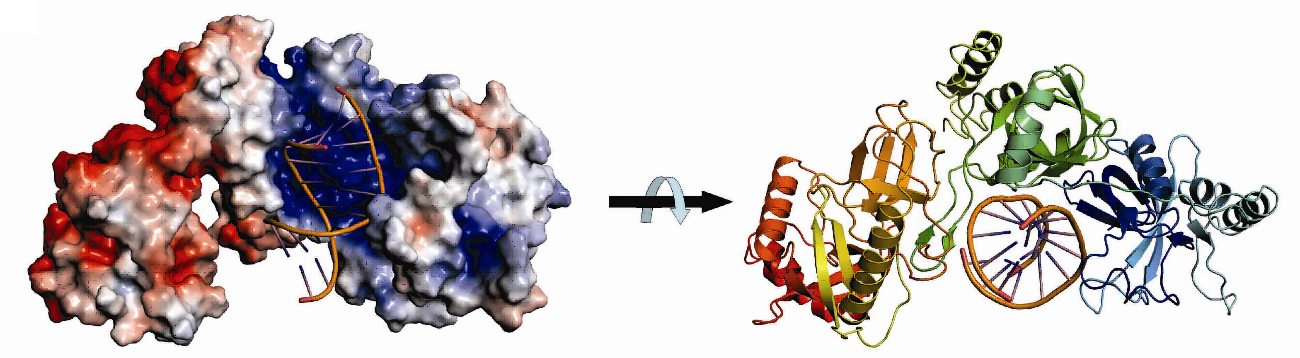

Structural model of a 64-kD Tudor-SN bound to double-stranded RNA. Our biochemical and structural data suggest that tandem repeats of SN domains in Tudor-SN work together to capture RNA substrates.

Publication:
Li, C.-L., Yang, W.-Z., Chen, Y.-P. and Yuan*, H. S. (2008) Structural and functional insights into human Tudor-SN, a key component linking RNA interference and editing. Nucleic Acid Res. 36, 3579-3589.

PNPase in mRNA degradation
PNPase (polynucleotide phosphorylase) is an important enzyme responsible for mRNA turnover from 3’- to 5’-end in bacteria. It shares a similar structural organization to eukaryotic exosome core complexes. Our structural and biochemical study on E. coli PNPase shows that the trimeric structure of a KH/S1-truncated PNPase is more expanded, containing a slightly wider central RNA-binding channel than that of the wild-type PNPase. This result suggests that the KH/S1 domain is involved not only in RNA binding but it also helps PNPase to assemble into a more compact trimer. This finding is likely a general phenomenon since only bacterial PNPase and archaeal exosomes with constricted channels are efficient enzymes in RNA degradation. We also study the structures and biochemical properties of human exosome component proteins and mitochondrial PNPase and their interactions with helicases to further characterize the structure-and-function relationship of PNPase in mRNA binding and degradation.

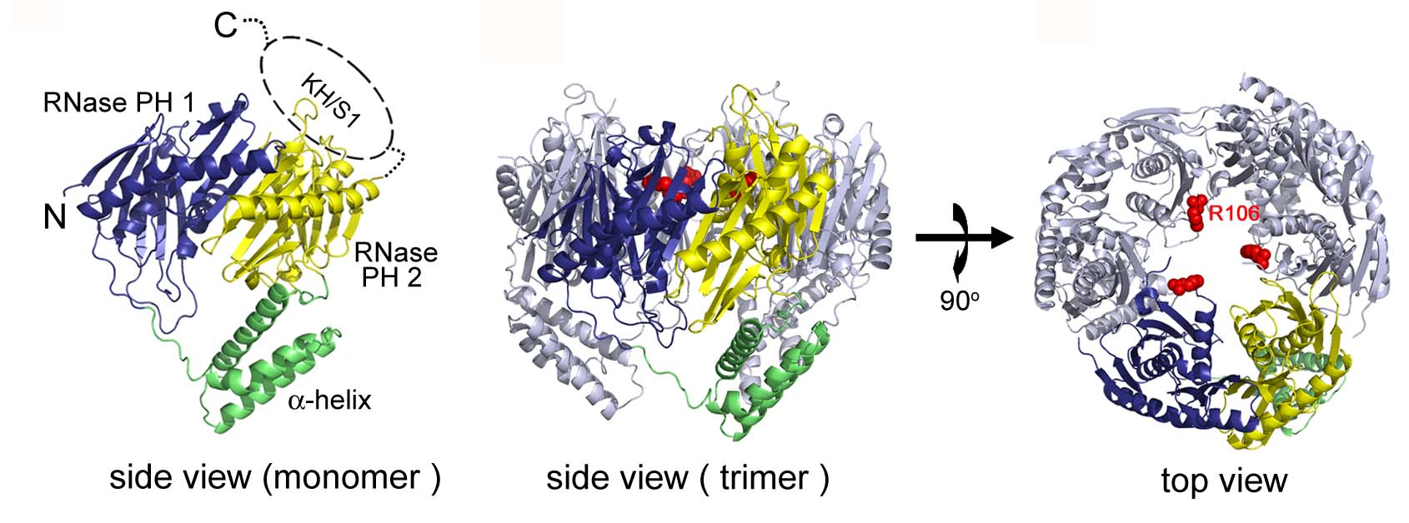
Crystal structure of E. coli PNPase. The homotrimeric PNPase is assembled into a ring-like structure which contains a central channel for RNA binding and digestion. Our structural and mutational studies show that the arginine residues located in the central channel play crucial roles in trapping RNA for processive exonucleolytic degradation.

Publication:
Shi, Z., Yang, W.-Z., Lin-Chao, S., Chak, K.-F. and Yuan*, H. S. (2008) Crystal structure of Escherichia coli PNPase: central channel residues are involved in processive RNA degradation. RNA, 14, 2361-2371.

Apoptotic nucleases in DNA degradation
Apoptotic nucleases are activated for chromosomal DNA fragmentation during apoptosis. Inactivation of these apoptotic nucleases produces undigested DNA and is related to a number of autoimmune disorders. We analyze the biochemical properties and crystal structures of a number of apoptotic nucleases to address the function of these nucleases in normal versus apoptotic cells. We determined the crystal structure of two C. elegans cell-death-related nucleases, CRN-4 and CRN-5. These studies provide new insights into the apoptotic nucleases in chromosomal DNA fragmentation. We also analyze the biochemical and structural features of several apoptotic proteins and nucleases that interact with CRN-4 to form a degradeosome in apoptosis, including CPS-6 (human Endo G homologue), WAH-1 (AIF), CRN-5 (Rrp46) and Cyp-13. The long-term goal of this research is to decipher the working mechanism of the degradeosome in DNA fragmentation during apoptosis.

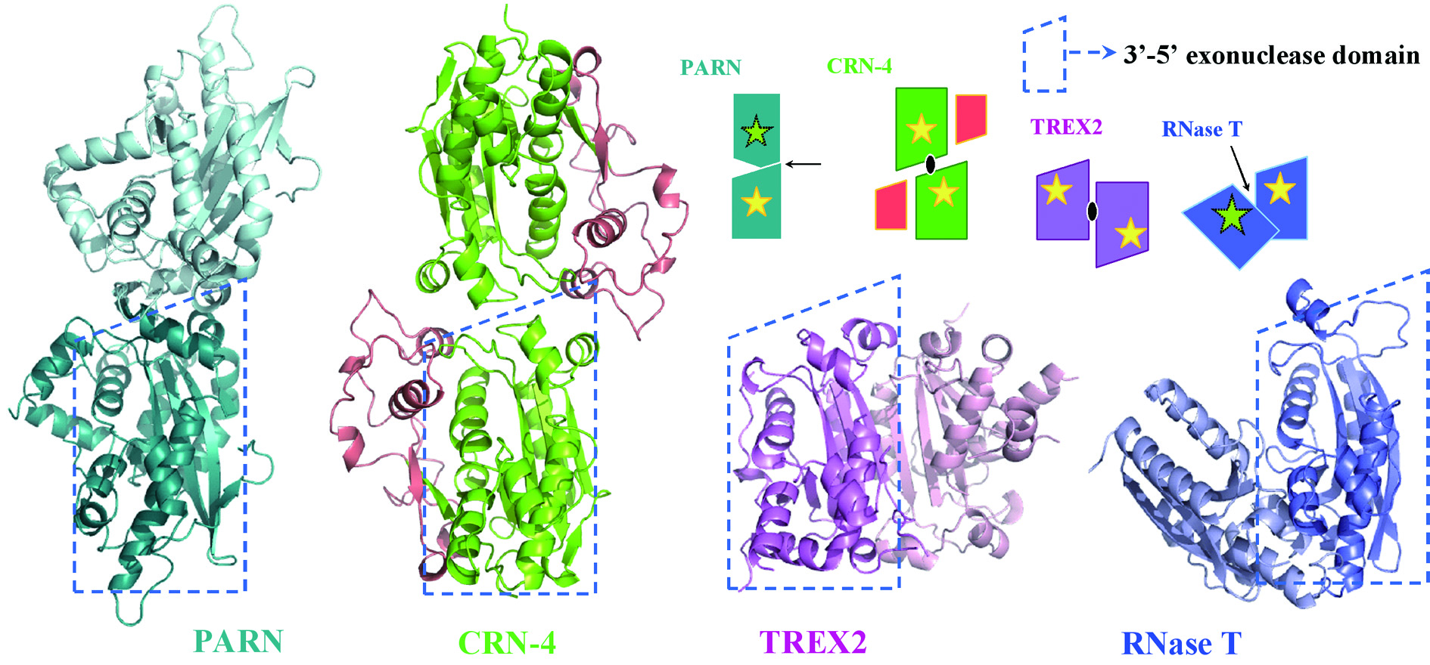

Crystal structure of CRN-4 and Comparison of the different domain arrangement in dimeic DEDDh family proteins. CRN-4 dimerizes in a different mode as compared to PARN, TREX2 and RNase T.

TDP-43 in RNA binding and neurodegenerative diseases
TDP-43 is a pathogenic RNA-binding protein: its normal function in binding to UG-rich RNA is related to cystic fibrosis, and inclusion of its C-terminal fragments in brain cells is directly linked to neurodegenerative diseases, including frontotemporal lobar degeneration (FTLD) and amyotrophic lateral sclerosis (ALS).
Based on the biochemical analysis data, we showed that the C-terminal TDP-43 RRM2 domain is capable of RNA binding and it forms a highly thermal-stable protein. The crystal structure of TDP-43 C-terminal RRM2 domain in complex with DNA further shows that RRM2 self associates to form fibril-like aggregates. Our results thus provide the molecular model for understanding the role of TDP-43 in cystic fibrosis and the neurodegenerative diseases related to TDP-43 proteinopathy.
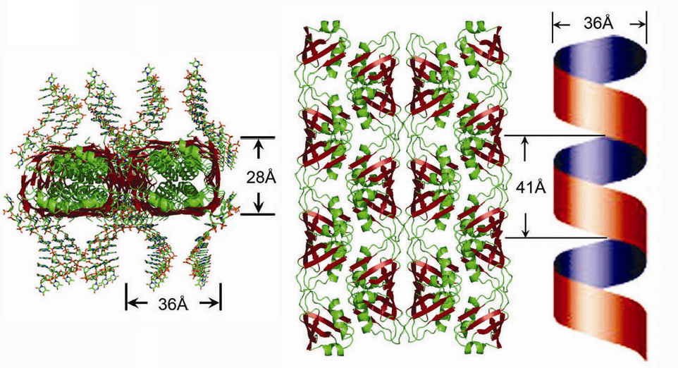

The RRM2 domain of TDP-43 forms a highly thermal-stable assembly. The crystal packing of RRM2 shows that the RRM2 dimers interact with the neighboring dimers to generate a left-handed super helix structure.

Publication:
Kuo, P.-S., Doudeva, L. G., Wang, Y.-T., Shen, C.-K. J. and Yuan*, H. S. (2009) Structural insights into TDP-43 in nucleic acid binding and domain interactions. Nucleic Acids Res, 37, 1799-1808.

- Bacterial nucleases in cell defense

We have been working on two types of sugar non-specific nucleases in bacteria, including a periplasmic nuclease Vvn and a secreted toxin ColE7, both of which digest foreign nucleic acids for cell defense. Based on our structural and biochemical analysis on Vvn and ColE7, we have provided a solid foundation to explain how these nucleases are inhibited and activated, how they recognize DNA without sequence specificity and how they digest DNA to protect bacterial cells at atomic level.
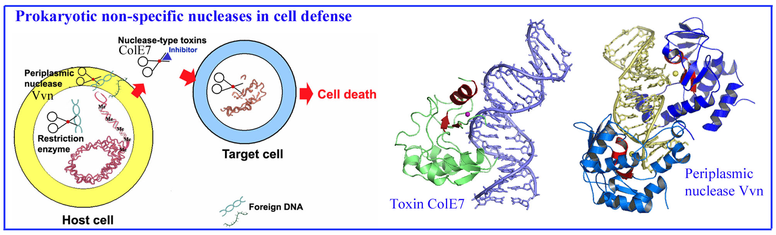
Related Publications:
Li, C., Ho, L.-I., Chang, Z.-F., Tsai, L.-C., Yang, W.-Z. and Yuan*, H. S. (2003) DNA binding and cleavage by the periplasmic nuclease Vvn: A novel structure with a known active site. EMBO J. 22, 4014-4025.
Hsia, K.-C., Chak, K.-F., Liang, P.-H., Cheng, Y.-S., Ku, W.-Y. and Yuan*, H. S. (2004) DNA binding and degradation by the H-N-H protein ColE7. Structure 12, 205-214.
Hsia, K.-C., Li, C.-L. and Yuan*, H. S. (2005) Structural and functional insight into the sugar-nonspecific nucleases in host defense, Curr. Opin. Struct. Biol. 15, 126-134.
Shi, Z., Chak, K.-F. and Yuan*, H. S. (2005) Identification of an essential cleavage site in ColE7 required for import and killing cells, J. Biol. Chem. 26, 24663-24668.
Cheng, Y.-S., Shi, Z., Doudeva, L. G., Yang, W.-Z., Chak, K.-F. and Yuan*, H. S. (2006) High-resolution crystal structure of a truncated ColE7 translocation domain: Implications for colicin transport across membranes. J. Mo. Biol., 356, 22-31.
Pan, Y. -H., Liao, C. -C., Kuo, C. -C., Duan, K.-J., Liang, P.-H, Yuan, H. S., Hu, S.-T. and Chak*, K.-F. (2006) The critical roles of polyamines in regulating ColE7 production and restricting ColE7 uptake of the colicin-producing Escherichia coli. J. Biol. Chem. 281, 13083.
Doudeva, L. G., Huang, H., Hsia, K.-C., Shi, Z., Li, C. -L., Cheng, Y. -S. and Yuan*, H. S. (2006) Crystal structural analysis and metal-dependent stability and activity studies of the ColE7 endonuclease domain in complex with DNA/Zn²⁺ or inhibitor/Ni²⁺. Protein Sci. 15, 269-280
Huang, H. and Yuan*, H. S. (2007) The conserved asparagine in the HNH motif plays an important structural role in metal finger endonucleases. J. Mol. Biol. 2007, 368, 3, 812-821
Wang, Y.-T., Yang, W.-J., Li, C.-L., Doudeva, L. G. and Yuan*, H. S. (2007) Structural basis for sequence-dependent cleavage by nonspecific endonucleases. Nucleic Acid Res. 35, 584-594.
Wang, Y.-T., Wright, J. D., Doudeva, L. G., Chen, H.-C., Lim*, C. and Yuan*, H. S. (2009) Design high-affinity nonspecific nucleases with altered sequence preference. J. Am. Chem. Soc. 131, 17345-17353.

