

Non-specific Nucleases in Cell Defense

A variety of non-specific nucleases are involved in cell defense by degradation of foreign or host nucleic acid molecules in prokaryotes and eukaryotes. We are interested in understanding and comparing the ways of how these nucleases are regulated, how they recognize DNA/RNA, and how they cleave phosphodiester linkages, using a combination of structural, biochemical and biophysical approaches.

We have been working on two types of sugar non-specific nucleases in bacteria, including a periplasmic nuclease Vvn and a secreted toxin ColE7, both of which digest foreign nucleic acids for cell defense. Based on our structural and biochemical analysis on Vvn and ColE7, we have provided a solid foundation to explain how these nucleases are inhibited and activated, how they recognize DNA without sequence specificity and how they digest DNA to protect bacterial cells at atomic level.

We also extend our investigation to the eukaryotic non-specific nucleases involved in cell defense. Specific projects include structural and functional studies of non-specific nucleases participating in chromosome fragmentation in apoptosis, and a number of RNases involved in mRNA degradation and miRNA biogenesis. For example, we determined the crystal structure of a cell-death-related nuclease (CRN4), suggesting how this protein binds and cleaves DNA in program cell death. Our structural and biochemical analysis on human Tudor-SN suggests how this protein captures hyper-edited miRNA and plays a role in RNA editing and interference. The long-term goal of this research is to establish molecular bases for how nucleases digest DNA/RNA to assert their roles in promoting or suppressing cell survival machinery.

Dr. Hanna S. Yuan 袁小琀

Research Fellow 研究員

- B.S. Chemistry Dept., Tunghai
University
- Ph D. Chemistry Dept. University of
Southern California, USA
1988- 92 PDF Mol. Biol. Inst., UCLA, USA

Selected Recent Publications:

1. Li, C., Ho, L.-I., Chang, Z.-F., Tsai, L.-C., Yang, W.-Z. and Yuan*, H. S. “DNA binding and cleavage by the periplasmic nuclease Vvn: A novel structure with a known active site” EMBO J. 22, 4014-4025 (2003).
2. Hsia, K.-C., Chak, K.-F., Liang, P.-H., Cheng, Y.-S., Ku, W.-Y. and Yuan*, H. S. "DNA binding and degradation by the H-N-H protein ColE7", Structure 12, 205-214 (2004).
3. Hsia, K.-C., Li, C.-L. and Yuan*, H. S. "Structural and functional insight into the sugar-nonspecific nucleases in host defense", Curr. Opin. Struct. Biol. 15, 126-134 (2005).
4. Shi, Z., Chak, K.-F. and Yuan*, H. S. “Identification of an essential cleavage site in ColE7 required for import and killing cells” J. Biol. Chem. 26, 24663-24668 (2005).
5. Cheng, Y.-S., Shi, Z., Doudeva, L. G., Yang, W.-Z., Chak, K.-F. and Yuan*, H. S. (2006) High-resolution crystal structure of a truncated ColE7 translocation domain: Implications for colicin transport across membranes. J. Mo. Biol., 356, 22-31.
6. Wang, Y.-T., Yang, W.-J., Li, C.-L., Doudeva, L. G. and Yuan*, H. S. (2007) Structural basis for sequence-dependent cleavage by nonspecific endonucleases. Nucleic Acid Res. 35, 584-594.
7. Huang, H. and Yuan*, H. S. (2007) The conserved asparagine in the HNH motif plays an important structural role in metal finger endonucleases. J. Mol. Biol. 368, 812–821.
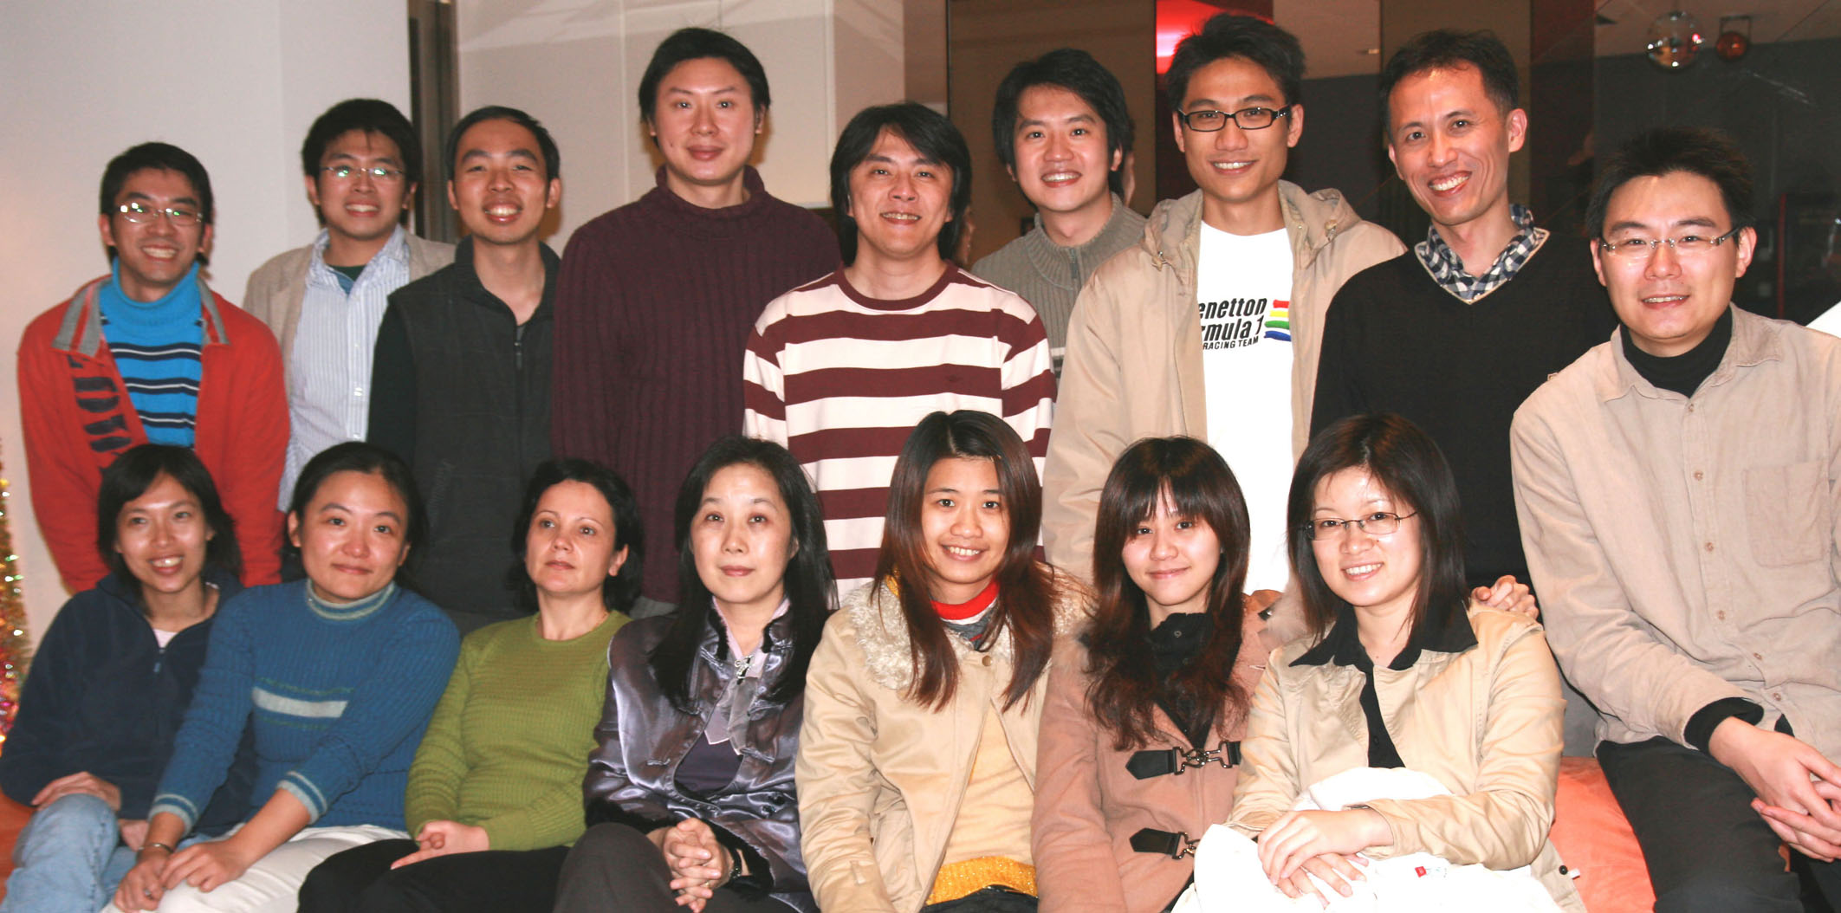

研 究 方 向
原核和真核生物細胞內，都含有一些非專一性的核酸水解酶。有些負責分解外來入侵的核酸，讓細胞能正常運作，不受外來基因的干擾。有些負責分解細胞內自己的核酸分子，參與核酸的代謝、生成或分解。我們的研究工作運用生化、分生和X光晶體結構測定方法，來了解這些參與細胞防衛或凋亡的核酸水解酶的功能，是怎麼被抑制、又怎麼被啟動，他們如何達成與DNA/RNA的辨識結合，以及如何分解DNA/RNA。
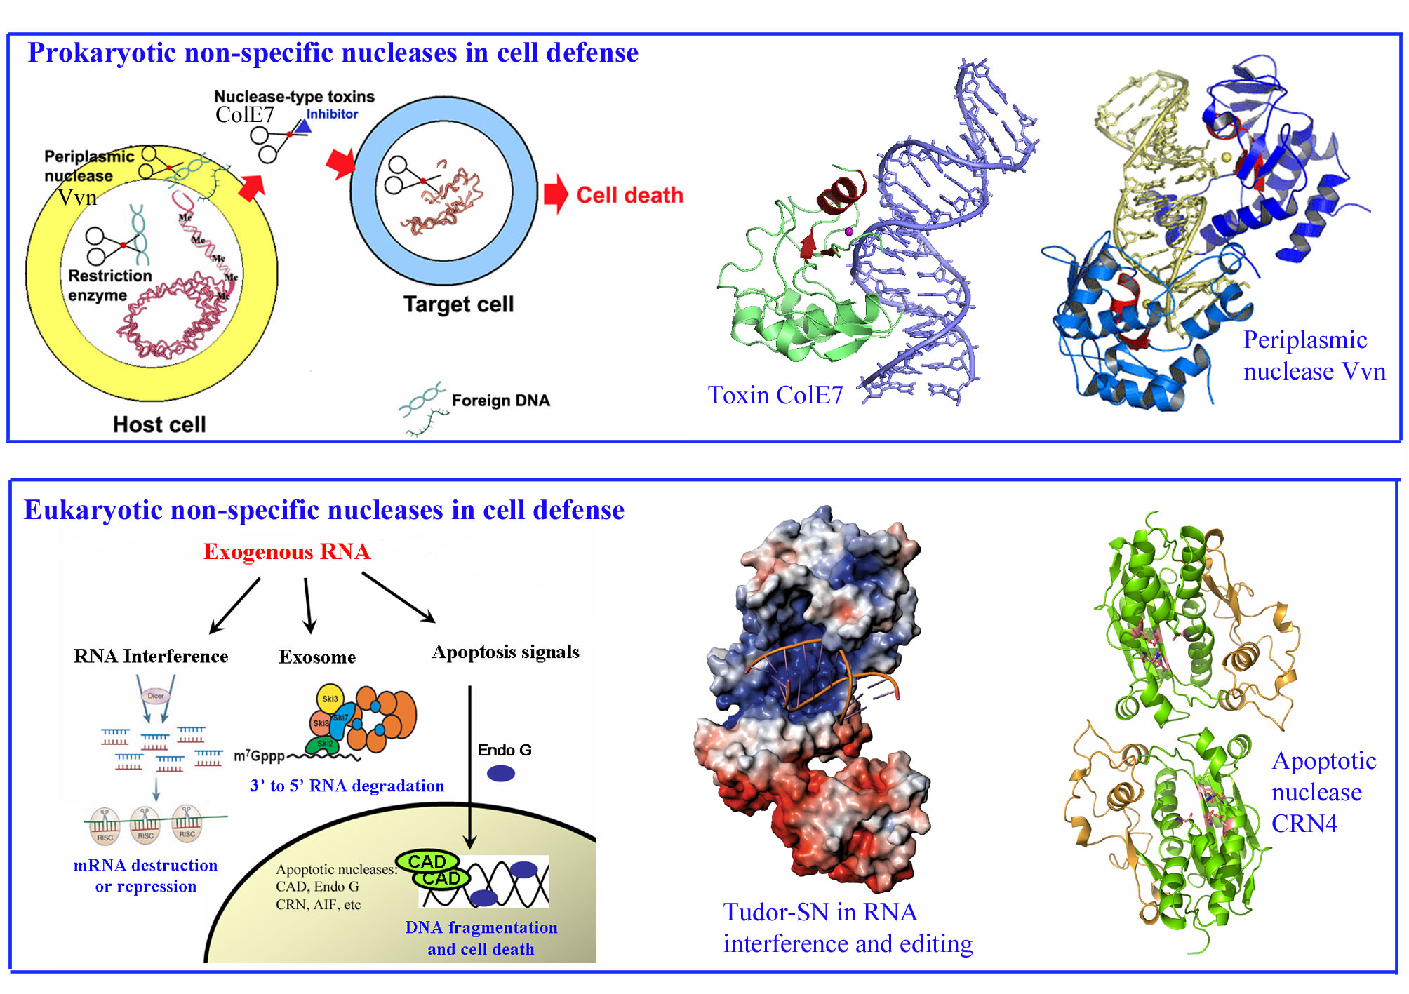

1-18-2008

我們過去分析了微生物中兩類核酸水解酶：Vvn與ColE7。配合生化分析的實驗結果，在分子層次上說明了這兩類核酸水解酶，如何被抑制蛋白質所調控，並如何不具專一性的分解DNA，而達到保護細胞的機制。近來我們也研究一些真核生物細胞內，參與分解DNA或RNA的蛋白質。好比參與細胞凋亡的核酸水解酶以及參與RNA分解的核酸水解酶。長遠來看，了解這些原核或真核核酸水解酶的作用機制，將有助於研發阻止或幫助細胞生存的方法。

